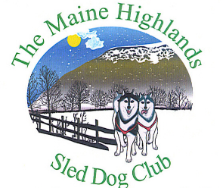

February 11, 2023 Bradford Sprint Race Results
February 12 Stage Race-12 miles

6 dog Mixed Breed
1st place- Charlotte Carroll 83.31.28
6 dog Nordic Breed
1st place-Jeff Ladd 100.17.17
2nd place-Jonathan Cote 106.08.14
4 Dog Nordic Breed
1st place-Autumn Ladd 105.19.14

Ski-jor-4miles
Nordic Breed
1st place-Margaret Stokes 23.57.07
2nd place-Al Paradis 29.51.84
4 Dog-4 miles
Mixed Breed
1st place-Shayla Stevens-20.33.19
Nordic Breed
1st place-Julia Klaucke-23.45.20
2nd place- Betsy Parker-30.33.45
3rd place-Matt Lad- 31.23.70
4th place- Melissa Dunn 32.35.15
5th place- Autumn Ladd 36.53.58
6th place-David Rea 43.53.36

6 Dog-6 miles
Mixed Breed
1st place-Shayla Stevens 26.03.51
2nd place-Charlotte Carroll 38.32.77
Nordic Breed
1st place-James Fitzgerald 36.17.48
2nd place-Julie Klaucke-36.39.57
3rd place-Jeff Ladd-44.19.81

2 Dog-2 miles
Mixed Breed
1st place-Shayla Stevens-20.31.79
Nordic Breed
1st place-Al Paradis 20.35.53
2nd place-Matt Ladd 25.36.20
3rd place- Don Banker 45.18.99
DNF David Rea

