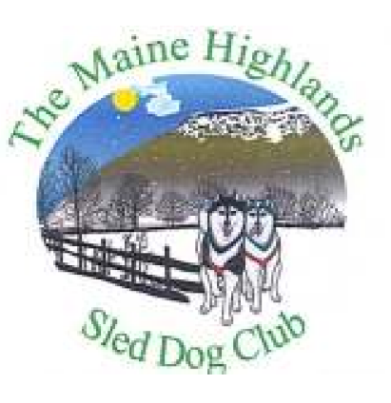
Bradford Sprint Race Results
(Awards through 3rd place)
January 15, 2022
Class/Division | Mixed Breed | Nordic Breed
6 Dog/6 mile | 1st-Brittany Colbath-23.05.02  2nd-Thomas Carroll-31.24.17  3rd-Shayla Stevens-38.39.94 | 1st- Joe Fitzgerald-34.33.38  2nd- Alek Quinn-35.10.02  3rd-James Fitzgerald-46.02.71  4th-Jeffrey Ladd-50.10.59
4 Dog/4 mile | 1st-Nova Clifford-14.23.90  2nd -Brittany Colbath-16.03.91  3rd- Carissa Daniels-16.40.17  4th- Tara Crossman-20.44.48  5th- Charlotte Carroll-21.52.75 | 1st-Jonathon Cote-28.17.07  2nd-Autumn Ladd-38.09.96
2 Dog/3 mile | 1st-Nova Clifford-14.16.21  2nd-Carissa Daniels-18.06.95  3rd-Isabella Cottrell-18.13.20  4th- Leendert Van Dorp-19.32.08  5th-Brittany Colbath-21.20.10 | 1st-Matthew Ladd-28.25.83  2nd-James Fitzgerald-30.14.83
1 Dog Skijor/4 mile | 1st- Leendert Van Dorp-21.15.47
2 Dog Skijor/4 mile | 1st- Veronica Jones-25.58.20
Recreation (no awards) | Nova Clifford-3.17.45  Isabella Cottrell-4.40.11  Thomas Carroll-6.04.33  Tara Crossman-6.07.33

