Maine Highlands Sled Dog Club
Resource Guide
Web Resources
Typical set-ups with prices from vendors
Types of Harnesses
Variety of Carts
Scooters
Bike Attachments

*Vendors are listed for informational purposes only, there is no club endorsement.
3/9/17-VP
Web Resources
- http://mainesleddogclub.com/ or https://www.facebook.com/The-Maine-Highlands-Sled-Dog-Club-184082871605885/
- http://www.mainemadedogsleds.com/
- https://www.ctcdoggear-usa.com/
- http://www.mtnridge.com/
- http://www.nooksackracing.com/
- http://ne-outfitters.com/
- http://www.outlawdogsleds.com/OUTLAW/Welcome.html or https://www.facebook.com/OutlawSleds/
- http://www.dogworks.com/
- http://dogcartusa.com/
- https://www.articrigs.com/
- https://www.sleddogcentral.com/
- http://dogscooter.com/products/books-brochures-and-dvds
- http://www.starlinghats.com/
- http://nesdc.org/
- http://desdc.org/ or
https://www.facebook.com/Down-East-Sled-Dog-Club-842734045738536/

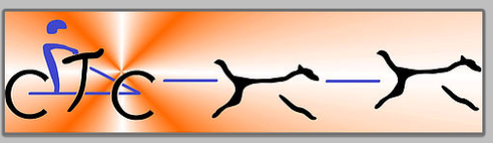

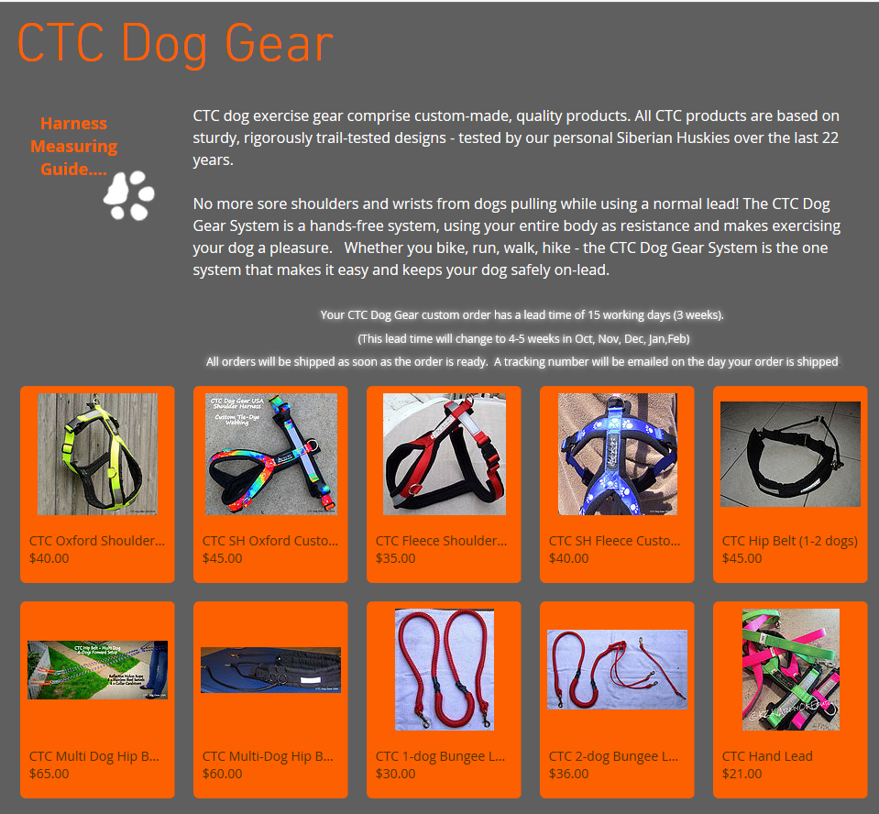

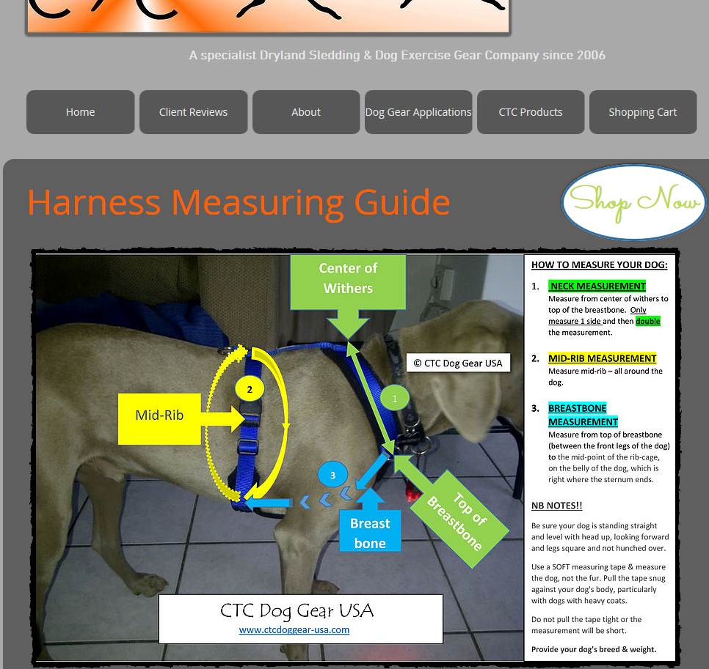

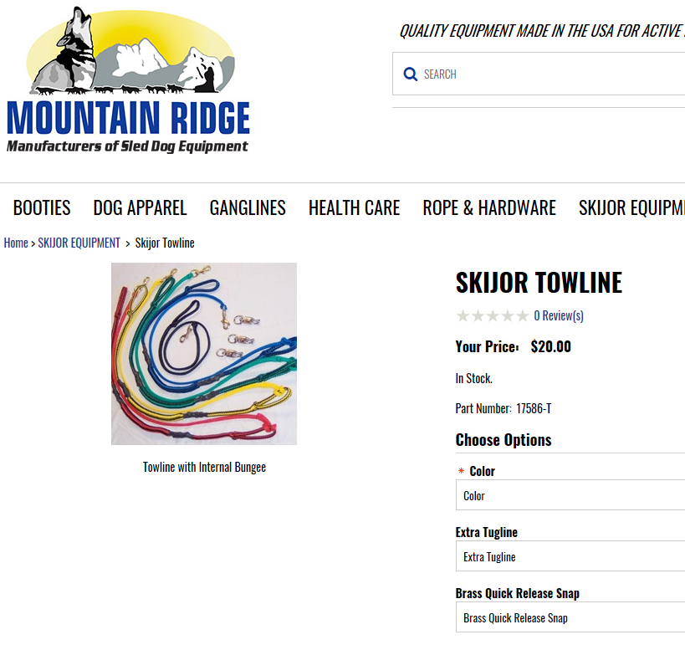
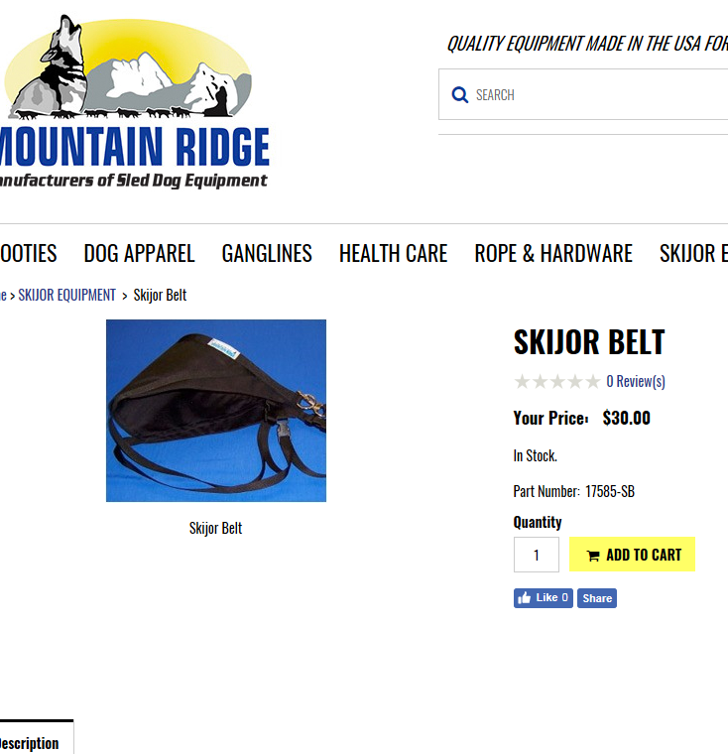

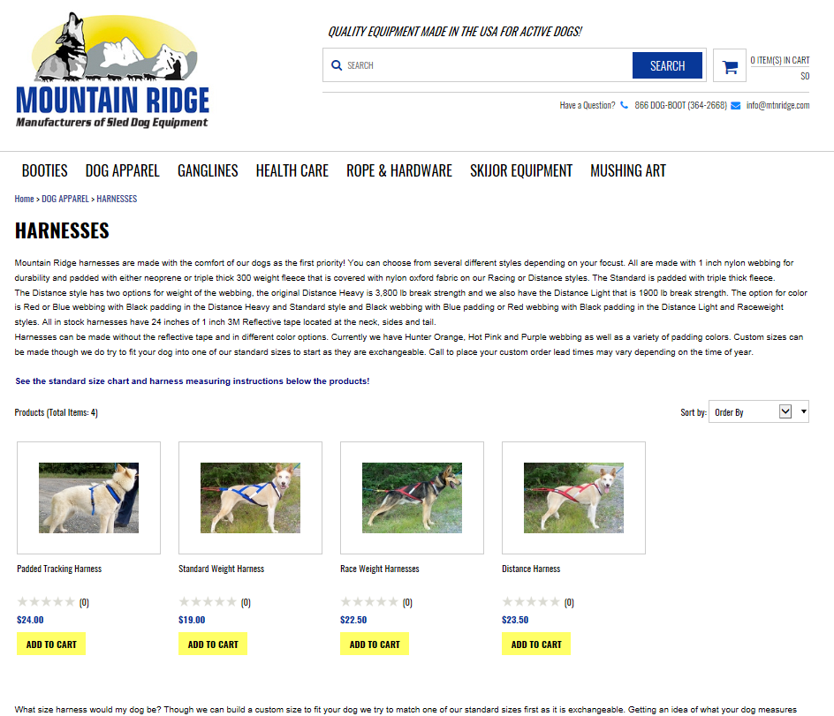

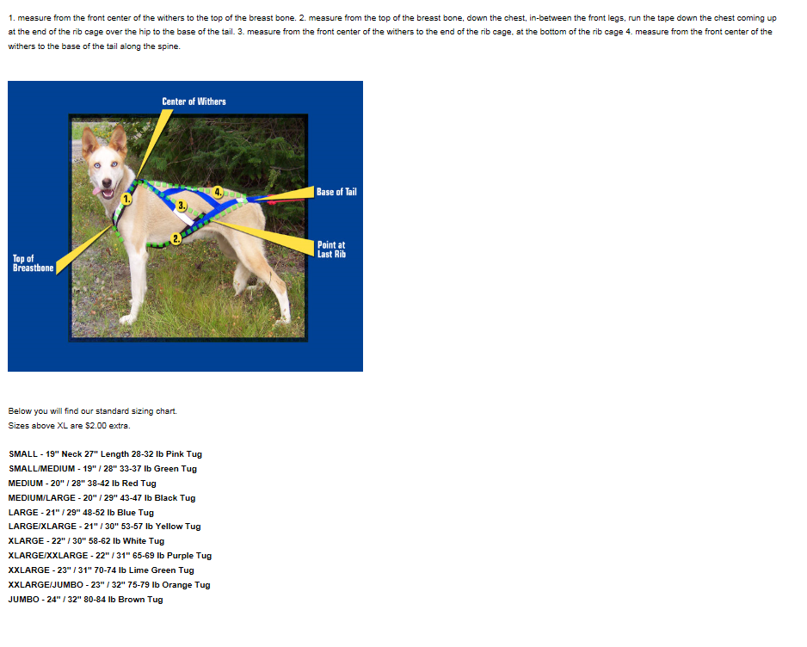

Nooksack Racing Supply
Nooksack Racing Supply (207)539-4324
E-mail: info@nooksackracing.com
www.NooksackRacing.com
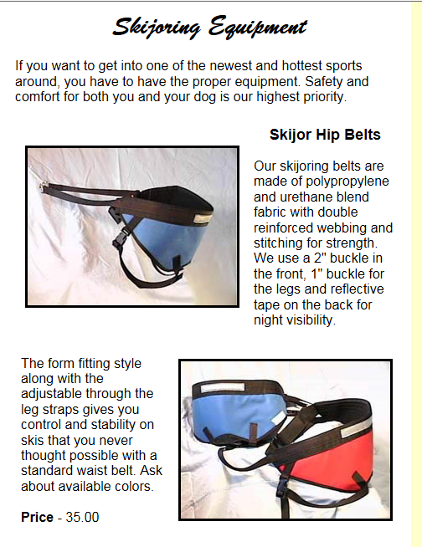

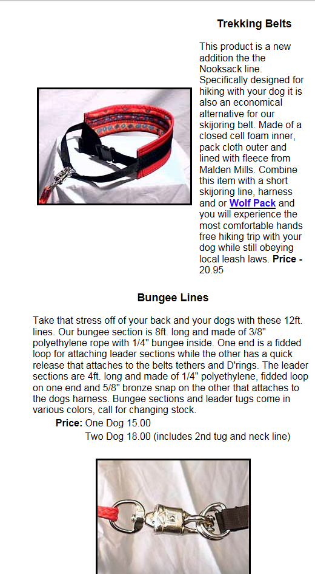
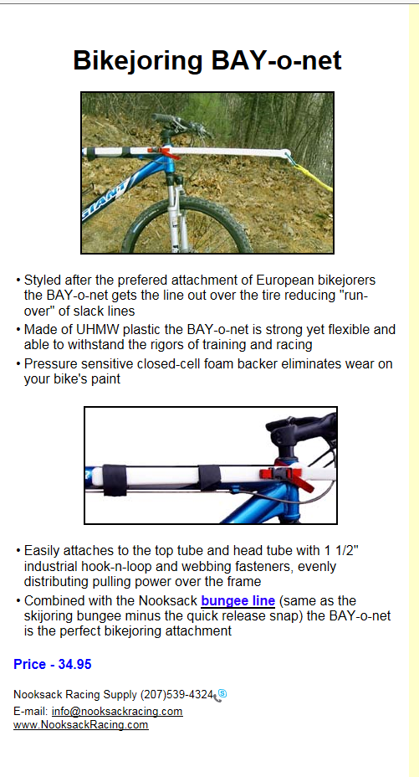
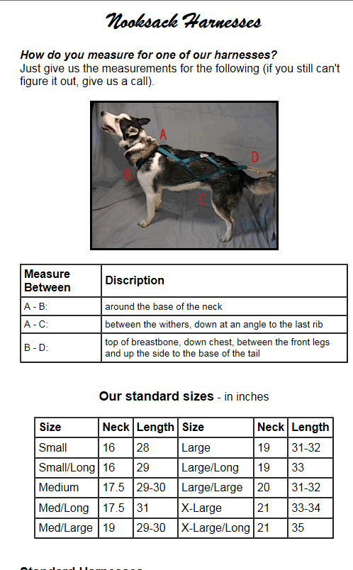

There are a multitude of harness types

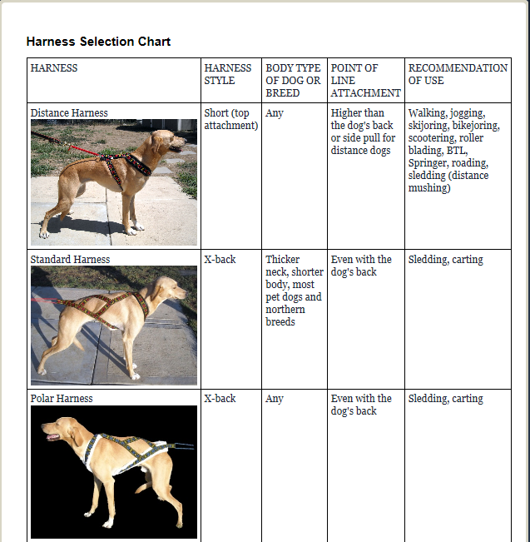

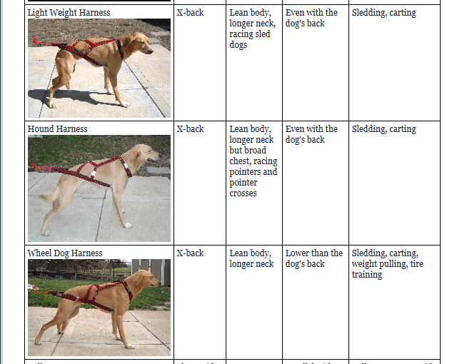
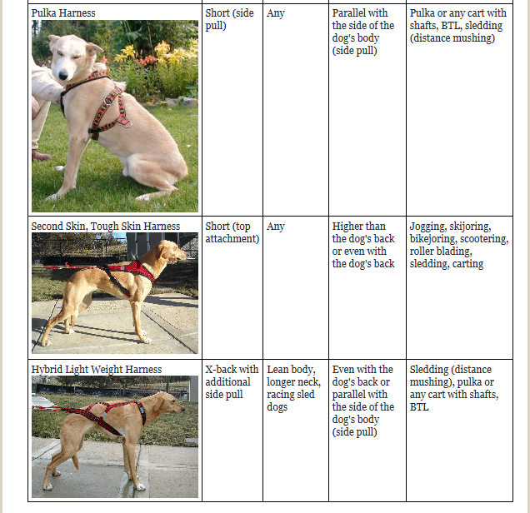

http://www.dogworks.com/

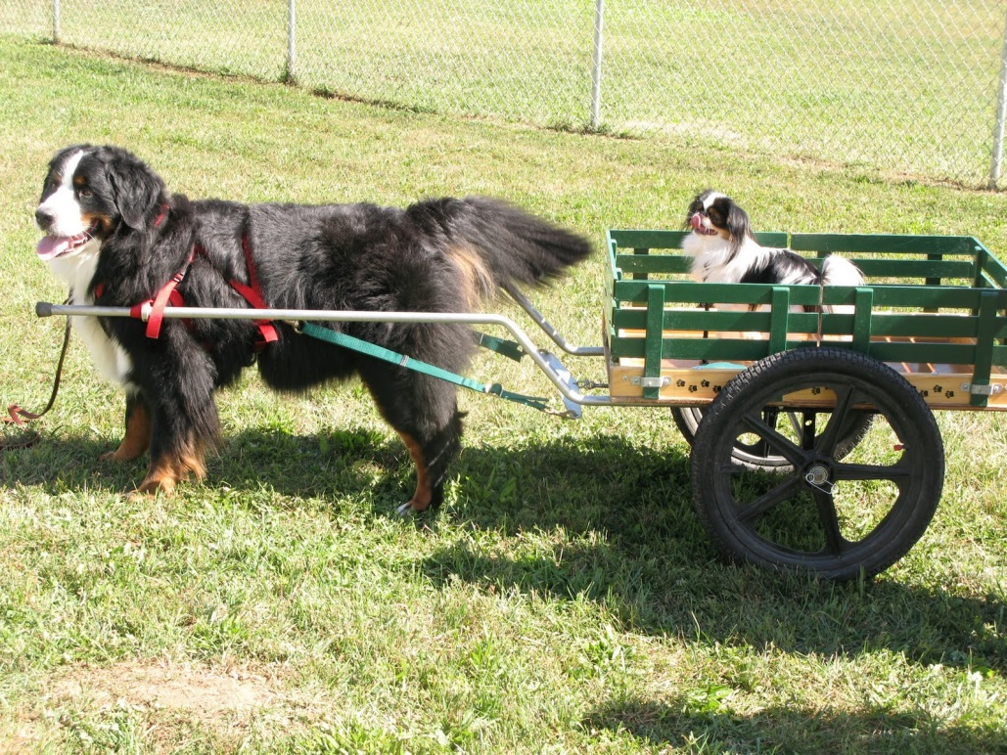

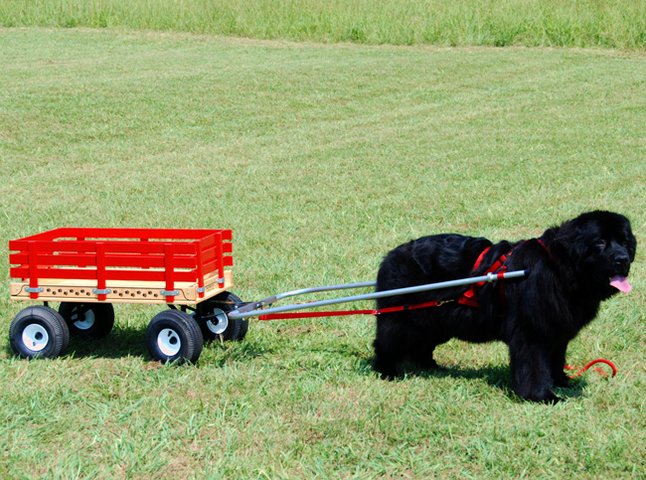

http://dogcartusa.com/
Sacco Dog cart
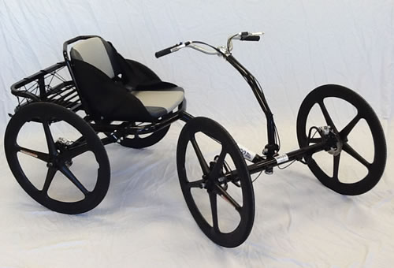

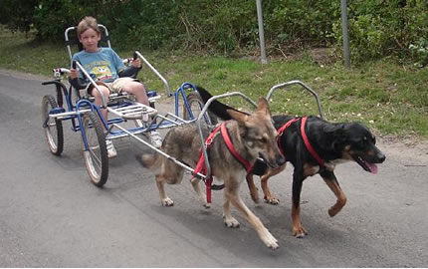

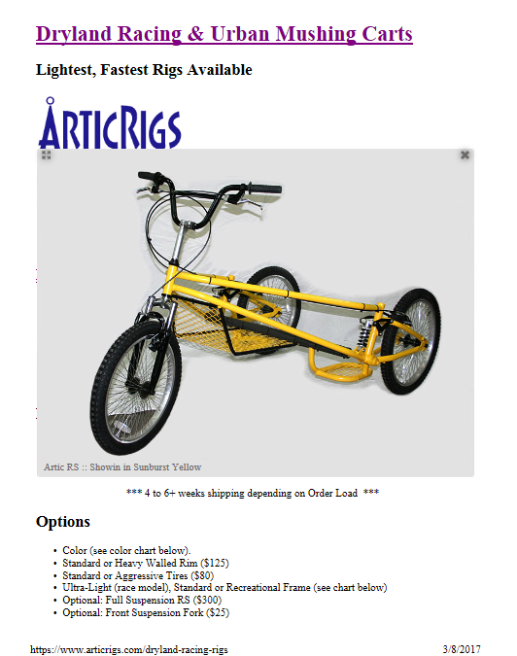

http://www.outlawdogsleds.com/OUTLAW/Media/transparent.gif
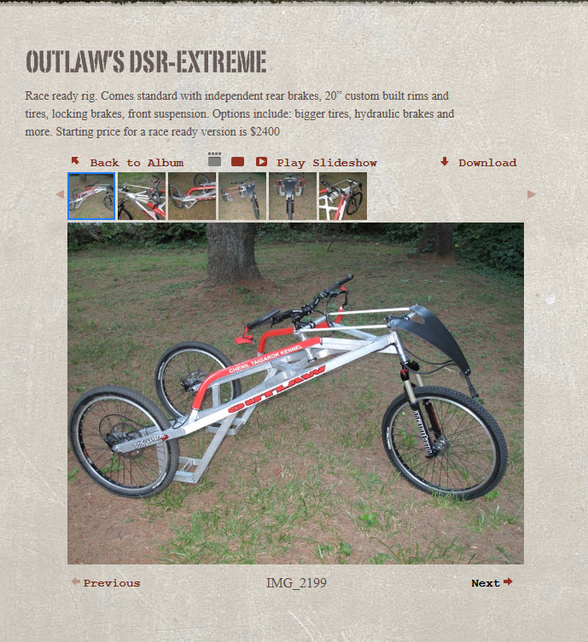

https://www.sleddogcentral.com/
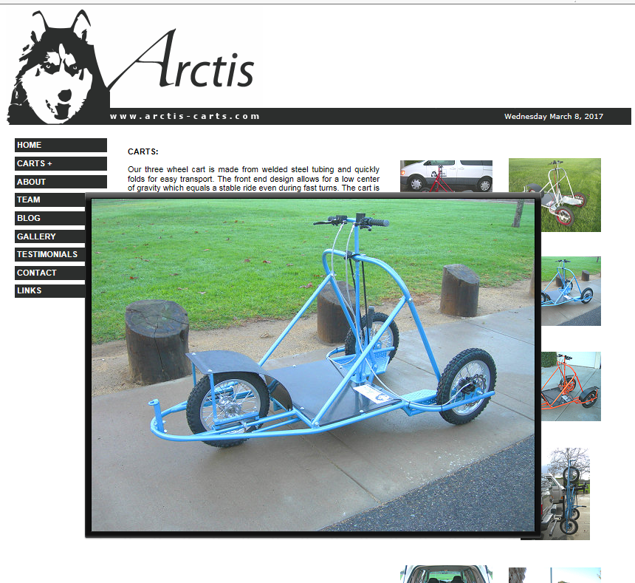

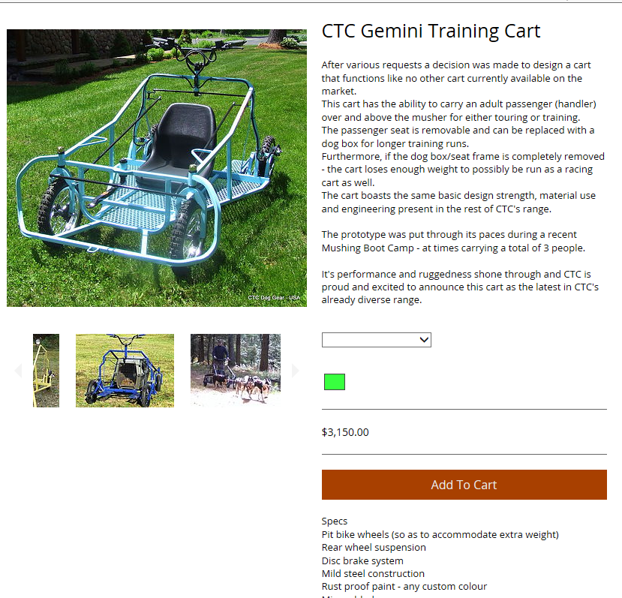

http://www.pawtrek.com/
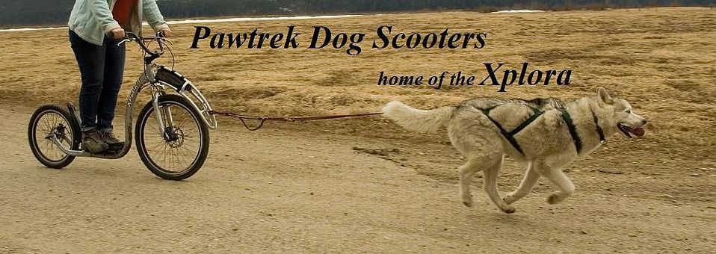
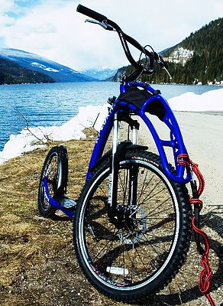

http://www.dogpoweredscooter.com/Photos.php
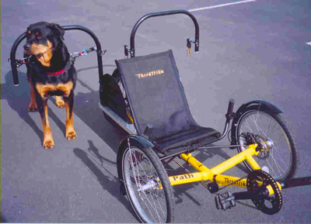
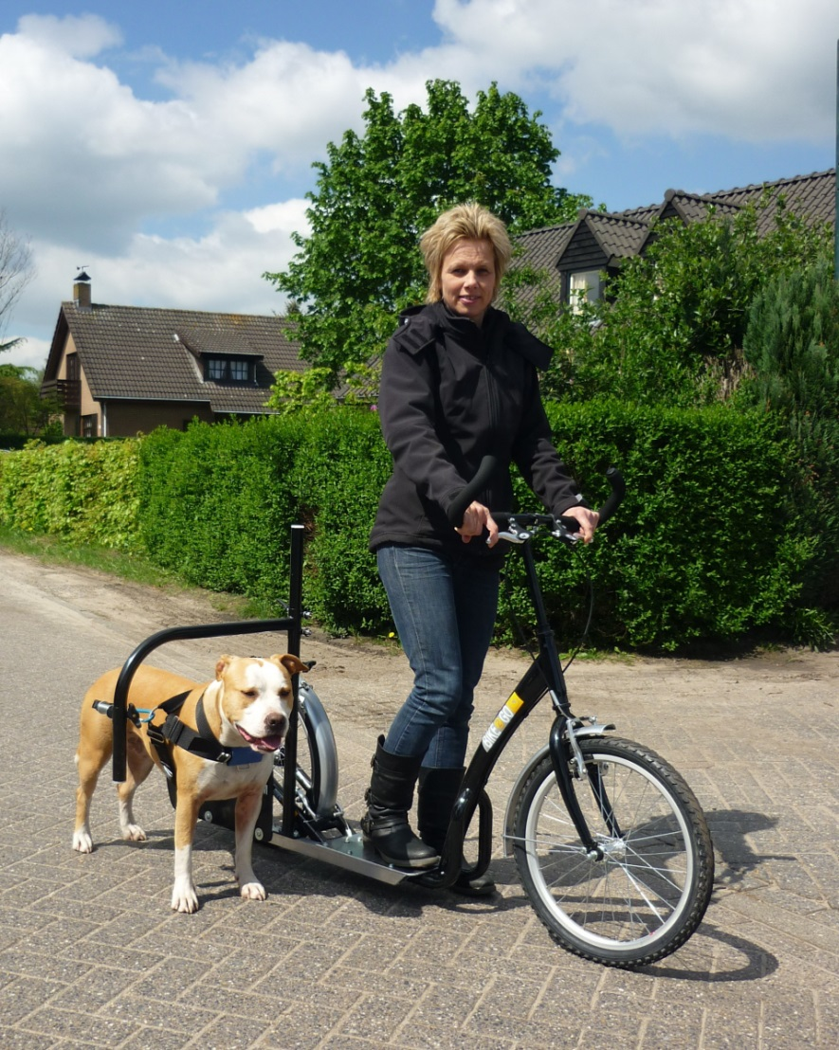

https://alpineoutfitters.net/scripts/openExtra.asp?extra=20
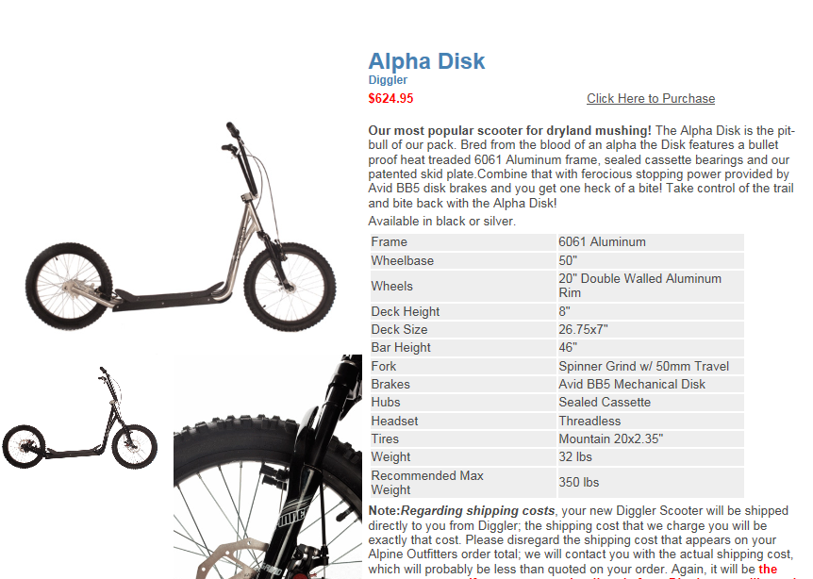

Variety of Bike Attachments available
http://www.thedogoutdoors.com/walkydog-plus-dog-bike-leash-deluxe-package.html

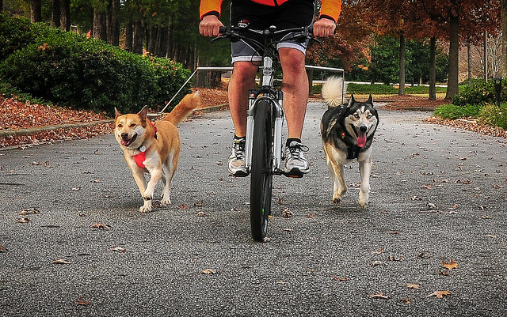
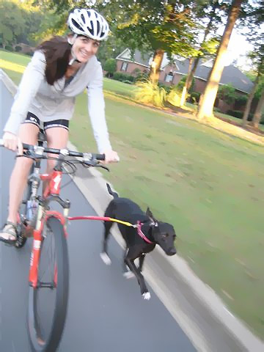
http://s513132788.initial-website.com/
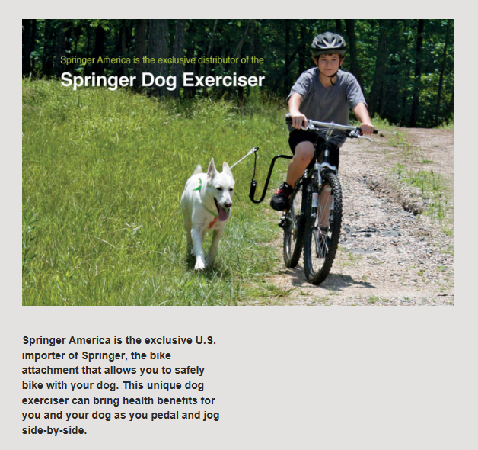

http://bikebalance.com/Details_Attachment_BikeDogLeash.html
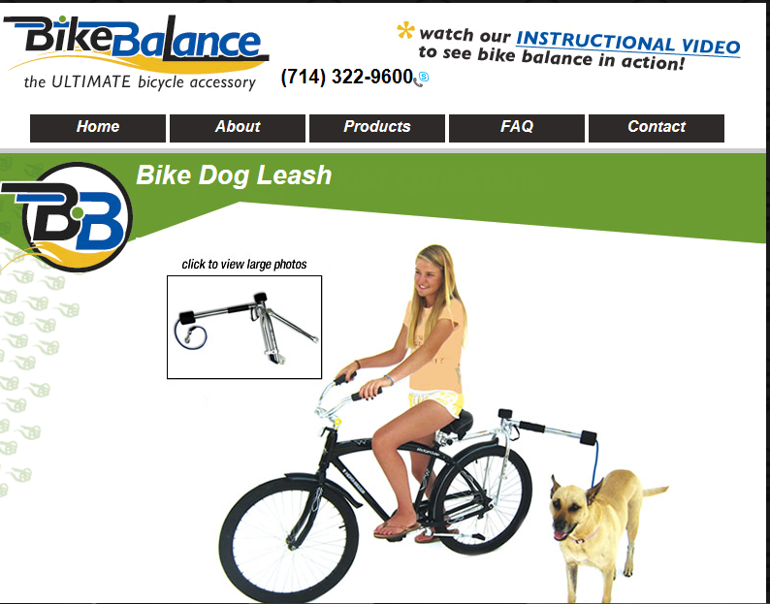

http://www.tugntowbikeleash.com/bike-joring
